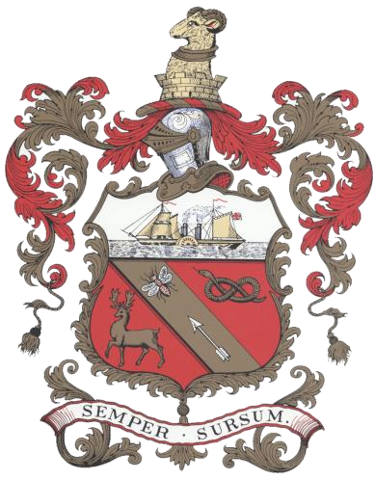

BARROW TOWN COUNCIL

MAYORAL CADET APPLICATION

Closing date for submission of applications is 6th May 2026

For the applicant’s parent / guardian to fill in

Name of applicant

Date of Birth

Name of parent / guardian

Address

Contact Number

Email Address

Declaration

I declare that:

The details given are correct, that I have not been influenced or canvassed in any way.

I understand that:

- This application form will be treated confidentially and in accordance with The Council’s Data Protection Policy.
- Barrow Town Council may ask for additional information at any stage of the application process.
- Should the present application fail, it may be resubmitted after the expiry of twelve months.
- All matters relating to the nomination are confidential.
- Any invitation for the appointed Mayoral Cadet to attend the Town Council’s civic events will be sent addressed to the Mayoral Cadet, all contact will be made via the approved parent / guardian of the Mayoral Cadet.
- The details provided will be kept for 1 year after I have completed my assignments.
- Details regarding data protection rights have been provided.

I give consent to Barrow Town Council storing the personal data above for the purpose of processing this application. | Signed:  Dated:

The Mayoral Cadet Role and Protocol

The role of the Mayoral Cadet role is to accompany the Mayor of Barrow to several appropriate public Civic Events during the Mayoral year, this includes amongst others Remembrance Sunday (a list of civic events is included on this form for your information).

At these events the Mayoral Cadet will assist the Mayor to welcome dignitaries and perform such duties as conducting a reading at an event or carrying a wreath for the Mayor on Remembrance Sunday.

The Mayoral Cadet also brings a visible association with the local uniformed organisations within the town, and a role that is considered to be an honour and reward for the applicant selected. The successful applicant will be given a badge to be worn on their uniform during their year in office.

For your information the following details the Mayoral Cadet Protocol

- A letter will be sent to all Uniformed Youth Organisations, youth groups and schools in the Town asking them if they had any youth member who wishes to be considered for Mayoral Cadet for the municipal year.

- The potential Mayoral Cadet would have to supply an endorsement by their group leader and parental consent. This is so we can contact them directly at home via their parents

- If in the event of multiple applications, a suitable selection process will be held to allow a
Mayoral Cadet to be chosen by the Mayor in liaison with the Clerk. If deemed suitable, the Mayor could choose a Deputy Mayoral Cadet for the Municipal year. This would ensure potential absences are covered.

- A list of civic events will be supplied to the Mayoral Cadet and their respective organisational in advance, although official invitations will be sent, directly to them prior to each event.

- The clerk will liaise with the Mayoral Cadet and their parents to ensure that the Mayoral Cadet is aware of key timings and roles at any Civic Function.

- The minimum age for the Mayoral Cadet should be 13 years old and no older than 19 years of age at the start of the Municipal Year.

- It will be expected that any Mayoral Cadet will be committed to attending our civic events throughout the year, will arrive dressed in appropriate uniform and will always conduct themselves to the highest standards. The Town Council understands that some of our civic events take place during the school week. The Mayoral Cadet is encouraged to obtain support from their school to attend events where appropriate.

- The Mayoral Cadet will be presented with a cloth Mayoral Cadet badge and metallic pin to wear on their uniform.

- The term of office is for one Municipal Year.

Mayoral Cadet Application

To be filled in by the applicant

In no more than 300 words please detail why you want to apply to become the Mayoral Cadet for the Municipal Year 2026/27

Uniformed Organisations Endorsement:

This can made by any adult leader within the applicant’s uniformed organisation.

Please explain below why you support the individual’s application.

Name of Group Leader
Email Address
In no more than 300 words please detail why this individual would be suitable for the Mayoral Cadet position
I give consent to Barrow Town Council storing the personal data above for the purpose of processing this application. |  | Signed:  Dated:

Civic Event Dates for Municipal Year 2026/27

DATES TO BE ENTERED | Armed Forces Flag Raise - 20th June 2026
 | Armed Forces Day - 27th June 2026
 | Battle of Britian - 20th September 2026
 | 125th Submariners Parade - 3rd October 2026
 | Remembrance Service Train Station – 7th November 2026
 | Remembrance Sunday - 8th November 2026
 | St Georges Day - 25th April 2027

Please note the above calendar dates are not exhaustive, and the successful applicant may be invited to additional appropriate events throughout the year.

